**IMPLEMENTING A PROGRAM FOR TIME SERIES DATA CLEANING, LOADING AND HANDLING TIME SERIES DATA AND PRE-PROCESSING TECHNIQUES**

**AIM**: To implement a program for time series data cleaning, loading and handling time series data and pre-processing techniques.

**PROCEDURE**:

1. Install necessary libraries
2. Import the libraries

import pandas as pd

import numpy as np

import matplotlib.pyplot as plt

import seaborn as sns

from sklearn.model_selection import train_test_split

from statsmodels.tsa.arima.model import ARIMA

from sklearn.metrics import mean_squared_error

1. Load the dataset

data = pd.read_csv('/content/crop_yield.csv')

1. Data pre-processing

data['Crop_Year'] = pd.to_datetime(data['Crop_Year'], format='%Y')

data.fillna(method='ffill', inplace=True)

1. Visualize

plt.figure(figsize=(12, 6))

plt.plot(data['Crop_Year'], data['Yield'], label='Crop Yield')

plt.title('Crop Yield Over the Years')

plt.xlabel('Year')

plt.ylabel('Yield')

plt.xticks(rotation=45)

plt.legend()

plt.show()

**OUTPUT**:

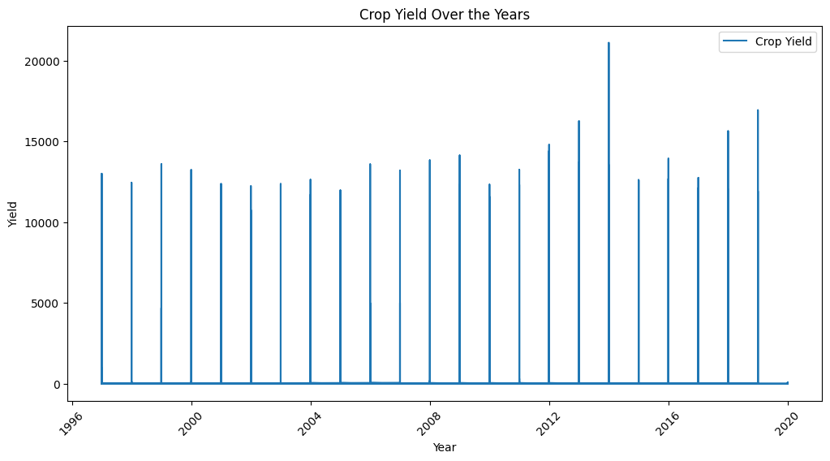

**RESULT**: Thus the program has been executed successfully.